CHAPTER 1: THE COMMUNICATION PROCESS

*Communication- the interdependent process of sending, receiving and understanding messages

Old model of communication→→→→ linear model
*Linear Model- communication as a one-way process; from the sender to the receiver

New model of communication→→→→ transactional model
*Transactional model- interdependent process; the speaker and receiver are simultaneously sending and receiving messages

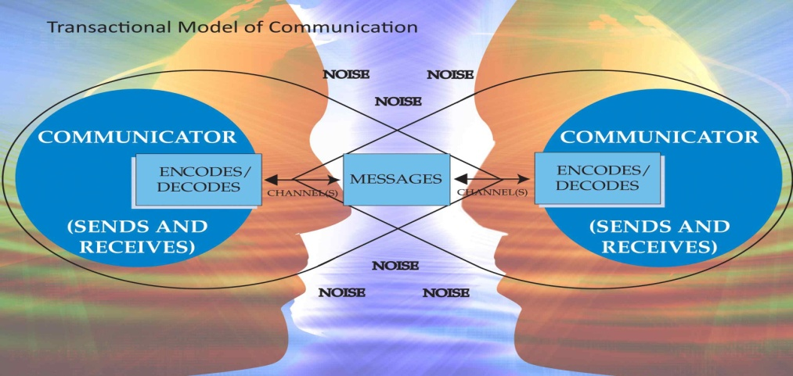
←←←FEEDBACK→→→

*Frame of Reference- allows us to create and interpret messages (encoding and decoding)
*Source- the person who creates and sends a message
*Receiver- the person the message was sent to; the receiver also sends messages back to the source
*Message- the thought, feeling, or action that is sent from the source to the receiver with the use of symbols (verbal and nonverbal)

*Channel- the vehicle (newspaper, radio, television, Facebook, Twitter etc.) by which the message is communicated from the source to the receiver
*Feedback- the receiver’s response to the sender’s message (verbal and nonverbal)
*Context- the conditions surrounding communication with others (physical setting and psychological climate)
*Noise- intended and unintended stimulus that affects the fidelity of a sender’s message, disrupts the communication process (external and internal)

FUNCTIONS OF COMMUNICATION
- Communication creates and maintains our sense of self or our identity.
- Communication helps us create communities.
- Communication forms and strengthens relationships.
- Part of being in a relationship is the ability to influence the other person.
- Communication conveys and creates information.
TYPES OF COMMUNICATION
*Intrapersonal Communication- communication with ourselves; it is an ongoing process that includes such activities as evaluating ourselves and our relationships with others, planning for the future and doing some internal problem solving
*Interpersonal Communication- the informal exchange between two or more people (dyads and small groups)
*Dyadic Communication- the interaction between two people
*Small Group- interactions with three to eight people present
*Public Communication- having an individual share information with a large group; the usual structure has a speaker presenting ideas to an audience

